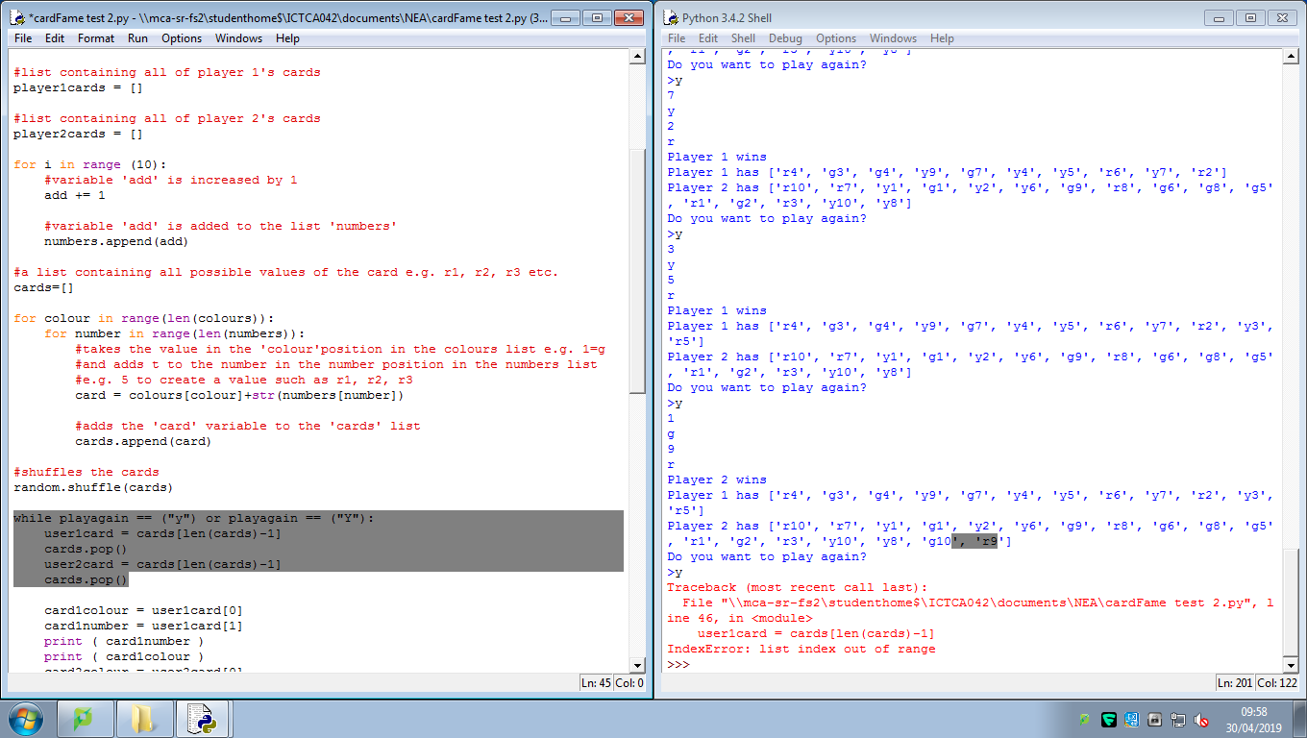

Once the 30 cards have been used up it tries to keep going but the deck is empty, resulting in an index out of range of -1.

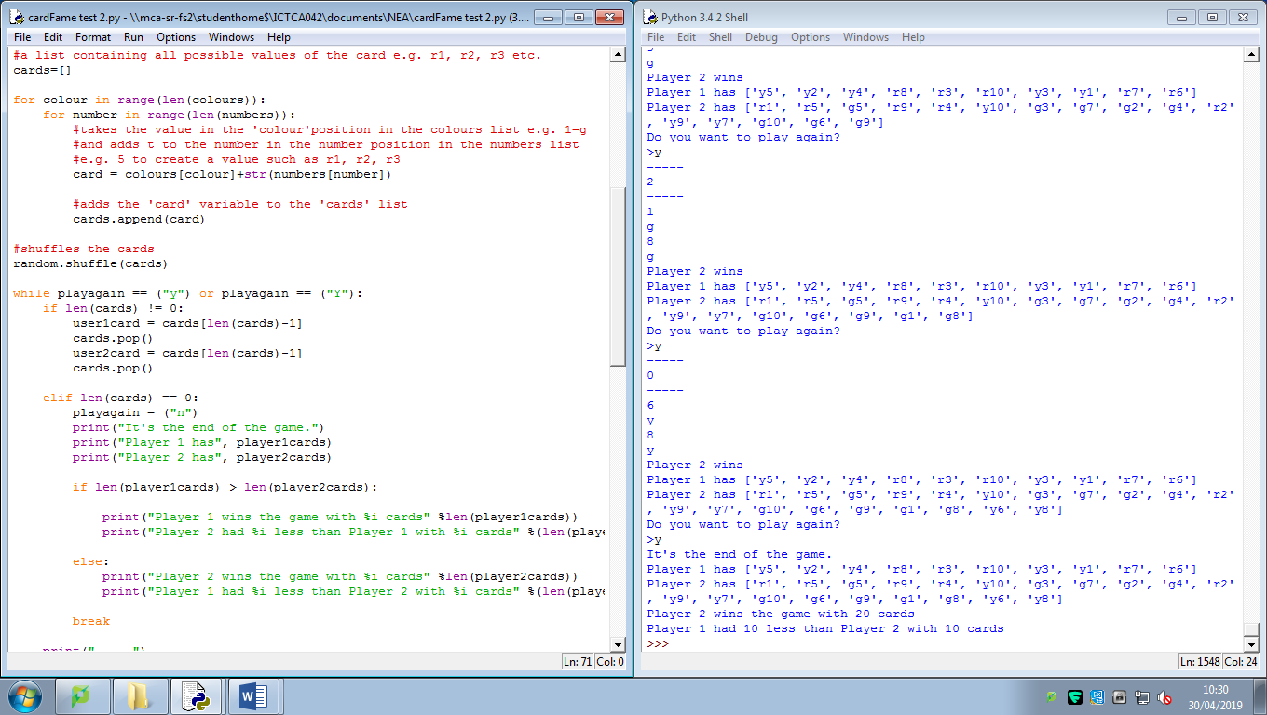

This works, however because the check occurs after the play script starts again, the players think they have another turn even though they don’t. This can be fixed by putting the check at the end of the play script.

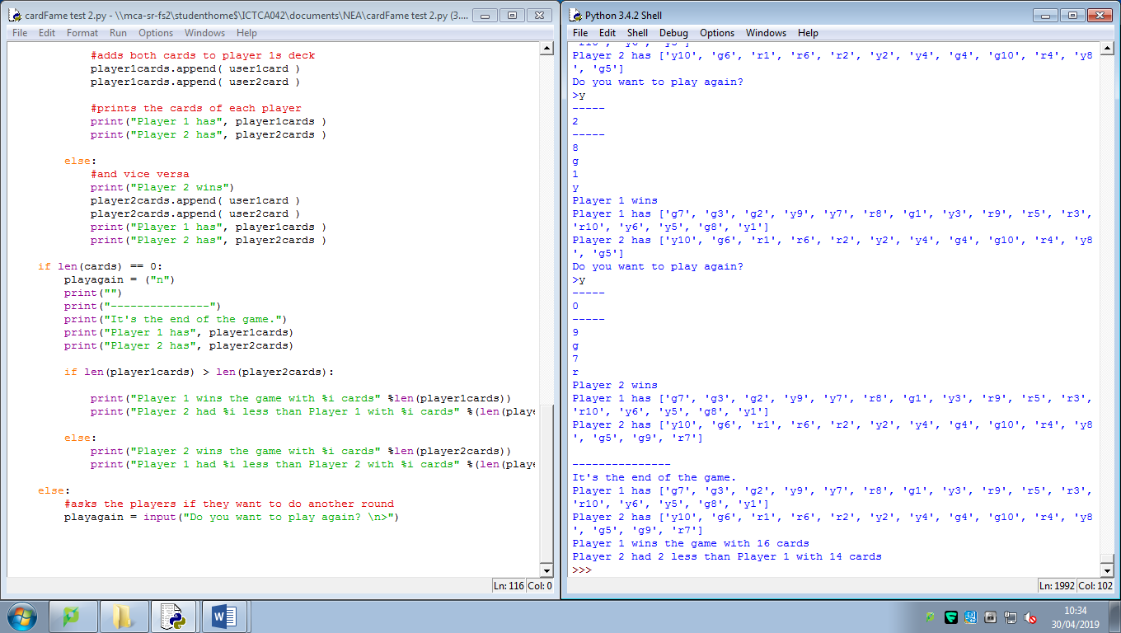

Wonderful.